Canvas :

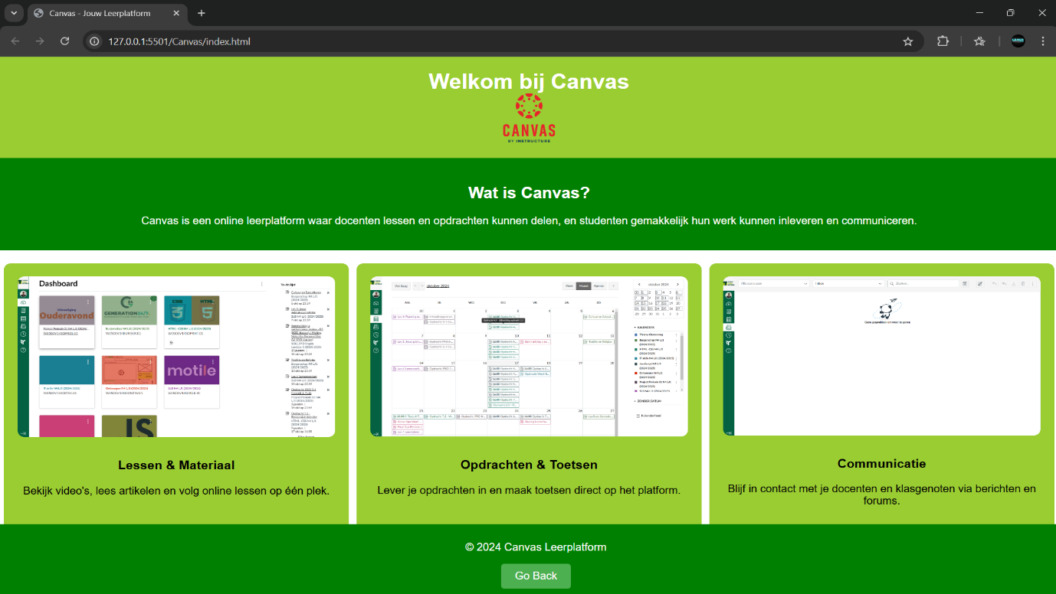

Eduarte:

Faciliteiten:

Locatiezaken:



